What trustyAI is all about?

<https://blog.kie.org/2020/06/trusty-ai-introduction.html>  
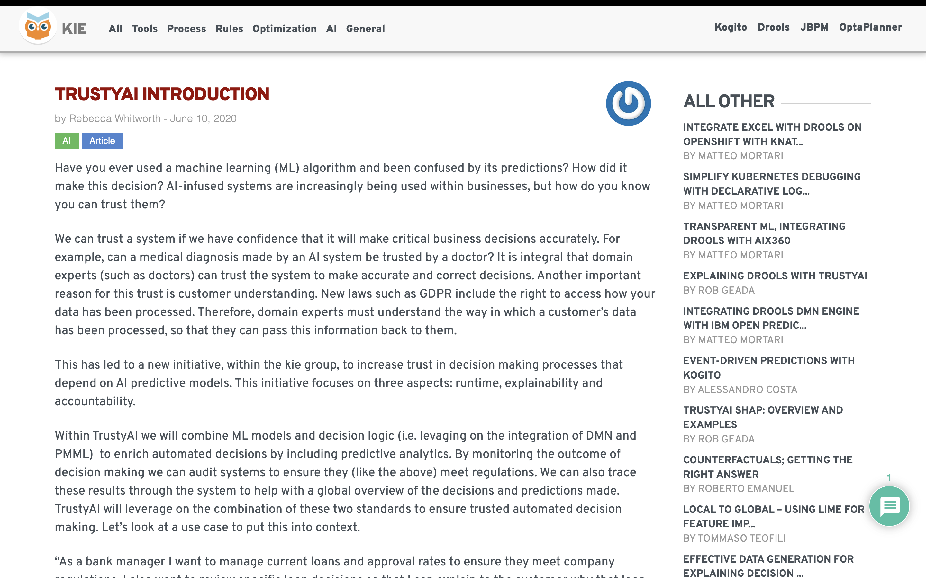  
  
Kie group   
  
Have you ever used a machine learning (ML) algorithm and been confused by its predictions? How did it make this decision? AI-infused systems are increasingly being used within businesses, but how do you know you can trust them?   
  
  
This initiative focuses on three aspects: runtime, explainability and accountability.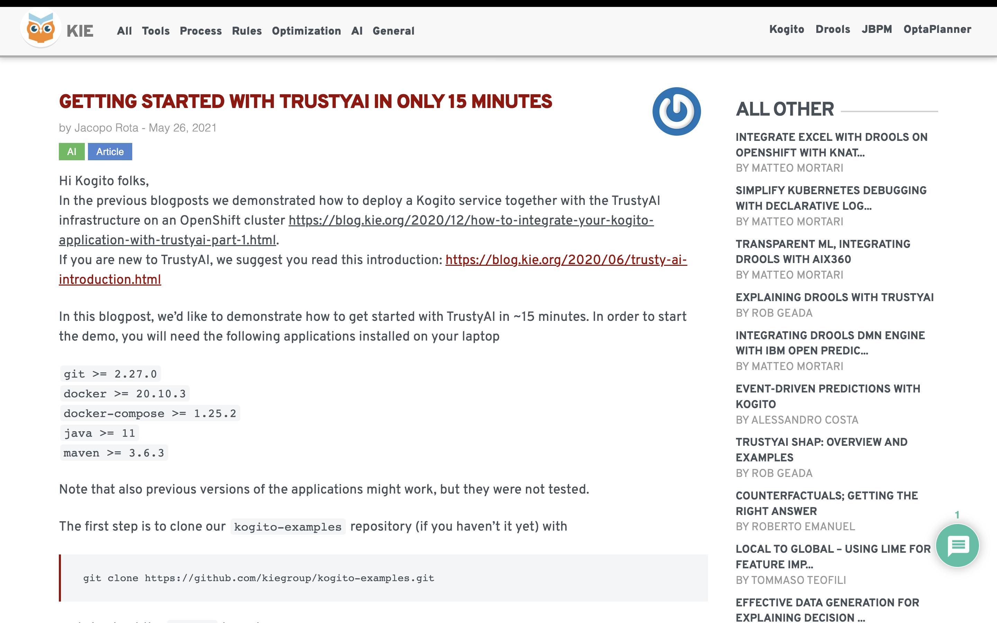   
  
  
<https://blog.kie.org/2021/05/getting-started-with-trustyai-in-only-15-minutes.html>  
  
  
  
what is a kogito application  
